
KENYAN FLAG AND NATIONAL ANTHEM

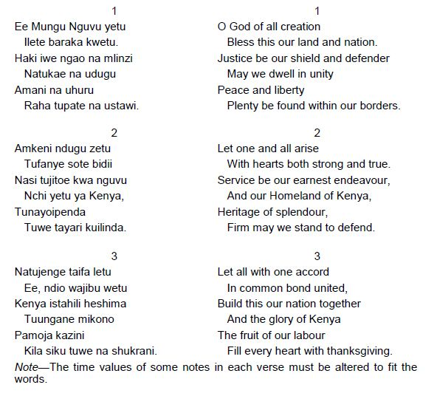
ENGLISH
KISWAHILI

